** PES University, Bangalore**

(Established under Karnataka Act No. 16 of 2013)

**MAY 2020: IN SEMESTER ASSESSMENT (ISA) B.TECH. IV SEMESTER**

**UE18MA251- LINEAR ALGEBRA**

MINI PROJECT REPORT

ON

**GAUSSIAN ELIMINATION USING TRAFFIC FLOWS**

Submitted by

1. Name: Ayushi Agarwal SRN: PES2201800053

2. Name: Aparna.R SRN: PES2201800345

Branch & Section : CSE – 4F

PROJECT EVALUATION

|  |  |  |  |
| --- | --- | --- | --- |
| Sl.No. | Parameter | Max Marks | Marks Awarded |
| 1 | Background & Framing of the problem | 4 |  |
| 2 | Approach and Solution | 4 |  |
| 3 | References | 4 |  |
| 4 | Clarity of the concepts & Creativity | 4 |  |
| 5 | Choice of examples and understanding of the topic | 4 |  |
| 6 | Presentation of the work | 5 |  |
|  | Total | 25 |  |

Name of the Course Instructor : Karthik Chandrasekhar

Signature of the Course Instructor :

**ABSTRACT**

The research paper presented here talks about the problems caused due to traffic congestion and the ways to resolve it using the applications of linear algebra.

We used a system of linear equations to determine the number of vehicles that

should be allowed to route a four one-way streets, in order to keep traffic

flowing. The systems of equations used in the model were solved analytically using

the method of Gaussian elimination followed by back substitution.This predicts the number of vehicles passing through each road. Also, matrices help in solving the problem with ease.

Also this paper helps in monitoring the traffic at various nodes in a network by knowing the optimal number of sensors to be deployed based on the link-path incidence matrix and comparing the two different network topology to get a better overview of the understanding. The paper also takes into account the various non mathematical models that can be made into use to solve the problems of traffic congestion like priority queue, change of direction etc. Thus, traffic jam is a serious issue in every big city and therefore needs to be taken care of.

**INTRODUCTION**

In mathematics and civil engineering, traffic flow is the study of interactions

between vehicles, drivers, and infrastructure (including highways, signage, and

traffic control devices), with the aim of understanding and developing an optimal

road network with efficient movement of traffic and minimal traffic congestion

problems. Current traffic models use a mixture of empirical and theoretical techniques.

These models are then developed into traffic forecast, to take account of proposed

local or major changes, such as increased vehicle use, changes in land use or changes in mode

of transport and to identify areas of congestion where the network needs to be adjusted.

This application involves modelling and predicting the flow of traffic through a network of streets.

**NEED TO SOLVE TRAFFIC CONGESTION**

(1)These include wasting time of motorists and passengers which therefore reduce regional

economic health delays, which may result in late arrival for employment,

meetings and education, resulting in loss of businesses, disciplinary action or

other personal losses.

(2)Blocked traffic may interfere with the passage of emergencyvehicles travelling to their destinations where they are urgently needed.

(3)Wasted fuel, increasing air pollution and carbon dioxide emissions owing to increasing

idling, acceleration and breaking of vehicles.

(4)Wear and tear on vehicles as a result of idling in traffic and frequentaccelerating and breaking, leading to morefrequent repairs and replacement of car parts.

(5)Stressed and frustrated motorists, encouraging road rage and reduced health of motorists.

**HOW DOES LINEAR ALGEBRA SOLVE OUR PROBLEM ?**

Traffic systems rely heavily on matrices:

* Measure traffic flow in and out of intersections.
* Direct the cycle of the traffic lights.
* Matrices provide organization for large amounts of data.
* Significantly improves travel efficiency by minimizing wait lines.
* Matrices in result display set of all possible solutions.

**WHY SYSTEMS OF LINEAR EQUATIONS:**

* In order to represent our collected flow rate data.
* Each equation represents a different part if the intersection.
* Gaussian elimination yields the solutions for unknown rates.
* Use to optimize traffic control.

**WHY CHOOSE GAUSS-ELIMINATION?**

* When ordinary elimination or substitution with more than 3 variables becomes cumbersome.
* The series of operations that are performed on the matrix of coefficients for reduction of matrix is called Gaussian elimination method.Gaussian Elimination method is a solution for matrix of the form Ax=b. Hence, we can obtain the values of the unknown by bringing it to row reduced echelon form followed by back substitution.
* For many scientific computations it is necessary to solve linear equation so good option is to solve it by algorithm of Gaussian elimination method.

**PERFORMANCE COMPARISON OF GAUSS ELIMINATION AND GAUSS-JORDAN ELIMINATION**

One of the most important applications of linear algebra is solving linear equations. Many problems of engineering, economics biology etc can be easily solved through linear equations to find the faster method of solving linear equation comparison between Gauss elimination and Gauss-Jordan elimination method, a comparative study of Execution time between Gauss Elimination method and Gauss Jordan method has been implemented by MAT LAB.

**TABLE : SUMMATIVE EXECUTION TIME**

|  |  |  |  |
| --- | --- | --- | --- |
| Numbers of Variables | Execution Time for Gauss Elimination method  (MacroSecond) | Execution Time for Gauss-Jordan Elimination method (MacroSecond) | Execution Time for Gauss-seidel Iteration method (Macro Second) |
| **2** | 254.4 | 318.4 | 996.2 |
| **3** | 299.6 | 374.8 | 1304.6 |
| **4** | 347.6 | 353.4 | 1068.4 |
| **5** | 389.4 | 398 | gauss-seidel method do not converge |
| **6** | 373.2 | 378.6 | gauss-seidel method do not converge |

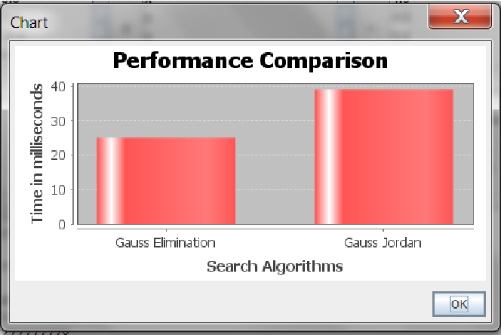

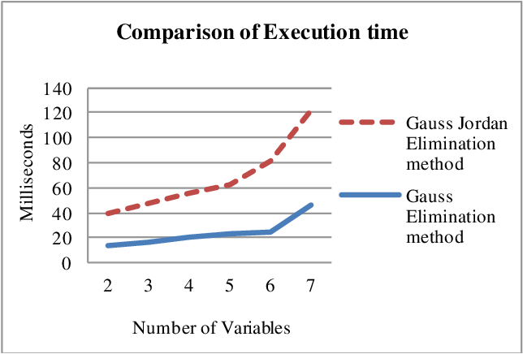

**Figure 3: Line Graph Among time taken by different Algorithm in MAT LAB**

After analysing the above table, conclusion can be drawn that generally Gauss Elimination Method is faster than the Gauss Jordan Elimination method and Gauss Seidel Iterative Method. The efficiency of Gaussian elimination method depends on the number of calculation involved in the solution of linear simultaneous equation. As the number of calculations increases; the efficiency of Gaussian elimination method decreases and vice-versa due to more time has been taken by algorithm in backward substitution.

The time taken by these algorithms implemented in MAT LAB software is far less than if same would be implemented by using C++, Java or any high programming language, due to support of Vector

Processing(parallel processing) while dealing with Matrix, by MAT LAB.

The Gauss Seidel Iterative Method is the slowest among all algorithms and suffers with problem of convergence (in our five and six variable case). Gauss Seidel Algorithm which is iterative algorithm can find the solution for linear system where the augmented matrix [A] has diagonally dominant coefficient.

**MATHEMATICAL APPROACH**

**1. Gaussian elimination:**

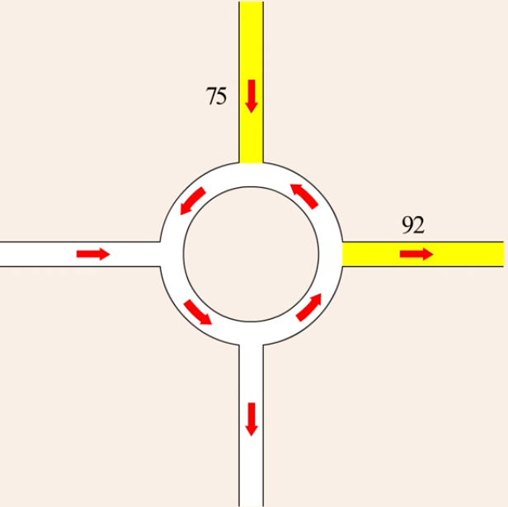

In our project, we take the example of a four one way junction and traffic circle to analyze the flow of traffic from YU research. We started by making a schematic diagram with arrows showing the direction of traffic flow in,out and around the traffic circle.

It was said that 75 vehicles per minute flowed into the circle from the north and 92 vehicles per minute flowed out to the east.

We observed that there was a high volume of traffic in through the north and out through the east due to which we reversed the direction of traffic in the circle between the north and the east intersection.

After these changes were made, measurements through west and south intersection was determined to be 56 vehicles per minute and traffic through the south and east intersection was found to be 23 vehicles per minute.

Following this, we also added a traffic cut through between the east and west sides of the circle so that there is an easy flow of traffic from west to east.

Since there were no traffic measurements in the remaining roads, we tried to calculate the missing traffic flow data by assigning variable to represent the traffic flow on each of the remaining roads.

So, we named it as:

x1 = Traffic through the north and west intersection road

x2 = Traffic entering from the west direction road

x3 = Traffic in the cut through between west and east direction roads

x4 = Traffic through the north and east intersection road

x5 = Traffic leaving in the south direction road

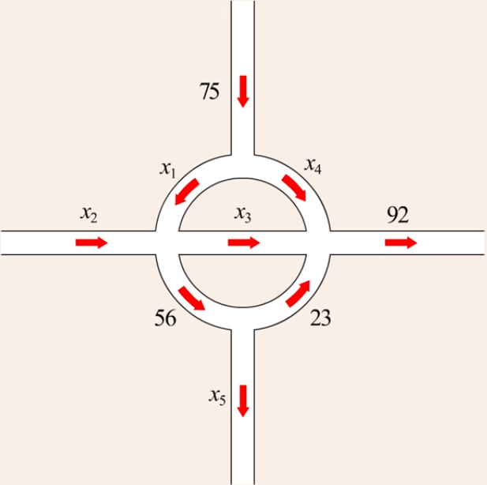

We then created a system of equation which we hoped will allow us to calculate the missing information.

Assumptions for the problem:

* Assume the number of vehicles entering an intersection equals the number of vehicles exiting.
* Assume constant traffic flow in between intersection.

Since traffic flow into the traffic circle = traffic flow out of the traffic circle,

x2 + 75= x5 + 92 ------------------------------------------------------------------------------- **I**

We also wrote equations for the traffic flow through the four intersections. Since Traffic flow into the west intersection = Traffic flow out of the west intersection,

x1 + x2 = x3 + 56 -----------------------------------------------------------------------------**II**

Since Traffic flow into the North intersection = Traffic flow out of the North intersection,

75 = x1 + x4 -----------------------------------------------------------------------------------**III**

Since Traffic flow into the East intersection = Traffic flow out of the East intersection,

x3 + x4+ 23 = 92 -----------------------------------------------------------------------------**IV**

Since Traffic flow into the South intersection = Traffic flow out of the South intersection,

56 = x5 + 23 -----------------------------------------------------------------------------------**V**

Hence we got a system of five linear equations with five variables x1, x2,x3,x4 and x5.

So we find the values of the five unknown variables with the help of **Gaussian elimination.**

Our first step was to simplify these linear equations i.e. combining all the constants to the right and all variables in each equation to the left,

x2 –x5 = 17 ------------------**I**

x1 + x2 –x3 = 17 ------------------**II**

x1 + x4 = 75 ------------------**III**

x3 + x4 = 69 ------------------**IV**

x5 = 33 ------------------**V**

This system of five linear equations can now be put into a matrix form,

x1 x2 x3 x4 x5



A matrix like this whose most entries are zero is called a sparse matrix.

Hence we get the reduced echelon form,



Hence by back substitution we get,

x1 + x4 = 75

x2- x3 –x4 = -19

x3 + x4 –x5 = 36

x5 = 33

* x3 + x4 = 3
* x2= -16

**B. Number of Sensors:**

In typical road traffic corridors, freeway systems are generally well-equipped with traffic surveillance systems such as vehicle detector (VD) and/or CCTV systems in order to gather timely traffic information for traffic control purposes. However, other highway facilities in the corridor, especially surface streets in the vicinity of the freeway, mostly lack sensor systems. Hence, there is a critical disconnect between the practical reality and methodological expectations in terms of detection capabilities. This research seeks to develop a mechanism to strategically deploy vehicle detectors to infer network origin-destination (OD) demands using limited link traffic count data. From an integration standpoint, it addresses the question of where to locate detectors on the non-freeway facilities so that, in conjunction with the installed detectors on freeways, the entire corridor can be managed effectively by obtaining the maximum possible accurate information on traffic conditions.

The primary goal is to address the network sensor location problem (NSLP) directly so as to obtain the unobserved link flows given the minimum subset of observed link flows provided by passive counting sensors.

**WHY DO WE NEED TO OPTIMIZE THE NUMBER OF SENSORS?**

The assumption of a network-wide traffic sensor system may not be realistic for practical applications due to the budgetary constraints of traffic management agencies. An urban network of moderate size can entail substantial costs to deploy a large number of sensors.

It motivates the need to address the problem of optimal sensor locations under a limited budget: **Can we identify a minimum subset of sensor installed links and their locations for accurate vehicular flow estimates throughout the network?** This problem or variants thereof can be broadly labelled as the network sensor location problem (NSLP). The link independence rule states that the sensor locations should ensure the linear independence of the traffic counts on the chosen links. They require the availability of a link-path incidence matrix and a historical O-D structure to solve these problems.The NSLP is an analog of the **“observability”** problem in linear system of equations.

**HOW BASIS IN A VECTOR SPACE AND RANK OF A MATRIX ARE RELATED TO THE CONTEXT OF OUR PROBLEM**

**Basis of a vector space:**

A basis β for a vector space V is a linearly independent subset of V that generates V.

By definition, the dimension l of V is the cardinality of a basis β of V. Then, any linearly independent subset of V that contains exactly l vectors is a basis for V.

**Rank of a matrix:**

The **rank** of a matrix is defined as

(a) the maximum number of lineary independent *column* vectors in the matrix i.e.column space.

or

(b) the maximum number of linearly independent *row* vectors in the matrix i.e.row space.

The rank of a matrix has the following properties:

1. The rows and columns of any matrix generate subspaces of the same dimension numerically equal to the rank of the matrix; that is, in a specific matrix the rank of the column space equals the rank of the row space.
2. Let A be an (m×n) matrix of rank r. Then r ≤m , and r ≤ n .
3. rank(A T ) = rank(A)

If β ={B1 , B2 ,..., Bl} is a basis for V and the matrix B =[B1, B2,…. Bl] , then any member v∈V can be written uniquely in the form v =Bw, wherewT **= {**w1 , w2 ,..., wl**}** is a vector of scalar coefficients.Then, any matrix Am×n in the vector space V can be represented by linear combinations of the elements B1,B2,….,Bl in B.

**Link-path incidence matrix and basis links**

A link-path incidence matrix is a 0-1 matrix that describes the network structure through the spatial relationships between the paths and links of that network. This matrix can be represented through a set of column or row vectors. If Lm×n denotes the link-path incidence matrix with m paths and n links, it can be expressed as:

Lm×n = [ L1 L2 …Lj…Ln ]

where Lj is the jth column vector of dimension (m×1).The basis of the vector space associated with Lm×n consists of l linearly independent column vectors, and the links corresponding to these columns are called the basis links. The remaining links in the network are called the non-basis links.If the flows on the basis links are observed using 11 sensors, then by definition of basis, the flows on all links can be inferred through linear combinations of the basis link flows. This conceptual platform is used here to address the NSLP.

**SOLUTION ALGORITHM**

**Reduced row echelon form**

A matrix is said to be in its “reduced row echelon form” if it satisfies the following three conditions :

1. Any row containing a nonzero entry precedes any row in which all the entries are zero (if any).
2. The first nonzero entry in each row is the only nonzero entry in this column.
3. The first nonzero entry in each row is 1 and it appears in a column to the right of the leading 1 in any preceding row. By definition, if the first non-zero number in a row is 1, it is called the leading 1.

The RREF for the link-path incidence matrix can be obtained using the Gaussian elimination algorithm. The associated steps are as follows:

**Step 1**: Locate the leftmost column of L that does not consist entirely of zeros.

**Step 2**: Swap the top row with another row, if needed, to bring a nonzero entry to the top of the column found in Step 1.

**Step 3**: If the entry that is now at the top of the column found in Step 1 is γ, multiply the first row by 1/γin order to introduce a leading 1.

**Step 4**: Add suitable multiples of the top row to the rows below so that all entries below the leading 1 become zeros in that column.

**Step 5**: Cover the top row in the matrix and begin again with Step 1 applied to the submatrix that remains. Continue in this way until the entire matrix is in row-echelon form.

**Step 6**: Beginning with the last nonzero row and working upward, add suitable multiples of each row to the rows above to introduce zeros above the leading 1’s. The resulting matrix represents the RREF of L.

Let L be an (m×n) matrix of rank r (r > 0) with column vectors L1, L2,…, Ln, and let T be the RREF of L. Denote the column vectors of T by t1, t2,…, tn. The RREF T has the following properties :

(a) The number of nonzero rows in T is r.

(b) For each k = 1, 2, …, r, there is a column vector tjk of T such that tjk=ek , where ek is an (m×1) unit column vector whose k th row element is 1. tjis the j th column vector in T.

(c) The column vectors of L, numbered Lj1, Lj2,….,Ljr , are linearly independent and denote the basis of the vector space associated with L.

(d) The reduced row echelon form of a matrix is unique.

Next, re-arrange T so that its first r columns are the linearly independent unit column vectors;

tjk=ek.Then, for consistency, we also re-arrange the column vectorswhere k = 1, 2, …, r

Lj1, Lj2, ….,Ljrto be the first r columns in L. Based on the re-arranged T and L matrices, the following property holds (Friedberg et al., 2003):

(e) For each j = 1, 2,…, n, if the j th column vector of T isα1 e1+α2 e2+...+αrer, then the

j thcolumn vector of L is α1Lj1+α2Lj2+ … + αrLjr, where α1,α2,…..,αr ,are the linear 14 combination coefficients.

We now state Lemma 1 assuming the re-arranged T and L matrices.

**Lemma 1**. Any column vector tj(j=1,2,…,n)in T can be represented by a linear combination of a set of r unit column vectors whose linear combination coefficients α are the column elements intjcorresponding to the r non-zero rows of T. That is, an (m×1) column vector tj= [α1α2 … αr 0 …. 0]Tin T can be represented astj= α1 e1+α2 e2+...+αrer.

**Proof.**

By property (a) of the RREF, the number of nonzero rows in T is r, the rank of L. By property (iv) of the rank of L, r ≤m , and r ≤ n ; and by property (iii) of the rank of L, the rank of the column space is equal to that of the row space. Let us assume that the row rank is r and m ≤n . Then, by definition r ≤m . There are two possibilities: r = m or r < m.

1. The rank of L is equal to the number of rows in L ( r= m ):

When the rank of L is equal to the number of rows in L, it implies the first r column unit vectors in T constitute an (r×r) square unit matrix. Then, by the definition of unit column vector, any column vector tj= [α1 α2 … αr 0 …. 0]T

1. The rank of L is less than the number of rows in L ( r< m ):

When the rank of L is less than the number of rows in L, by property (a) of the RREF, the number of nonzero rows in T is r. It implies that the bottom (m-r) rows of T are zero rows. Then, any column vector tj in T has the form

tj**=** [α1 α2 … αr 0 …. 0]T with the last (m-r) elements being zeros. Also, based on the re-arrangement of T and property (b), there is a sub-matrix in T which is an (m×r) unit matrix whose column vectors are r unit column vectors e1, e2,…, erof dimension (m×1). Therefore, any column vector

tj**=**[α1 α2 … αr 0 …. 0]T in T can be represented astj= α1 e1+α2 e2+...+αrer.

This logic can be repeated if n ≤m , that is, r ≤ n. This completes the proof.

**Discussion on multiple solutions**

Multiple solutions in terms of the set of basis links can exist for a given network structure represented by the link-path incidence matrix L. Since the ordering of the column vectors in L is arbitrary, the column positions of the links in L can decide the set of basis links due to the steps of the Gaussian elimination algorithm for the RREF. Hence, if multiple solutions exist, they can be determined by simply varying the specific locations of link column vectors in L. In the algorithm, the leftmost columns are processed first to identify basis links. Hence, if traffic agencies prioritize links in some order of importance, they can be considered seamlessly in the proposed basis link method by assigning the higher priority links to the leftmost columns in L.

**Identical column elements in L or T**

Any pair of columns with identical coefficients in L or T will have the same link flows. Hence, a non-basis link with a column vector in L or T that is identical to that of a basis link can be swapped with the basis link to enter the basis. This implies multiple solutions in terms of the set of basis links.

**Swappability of the column pairs in T**

If a pair of columns in T does not have identical column elements, multiple solutions exist if they are swappable. Here swappability means that after swapping any column pair, the non-basis link becomes a basis link, and the basis link becomes a nonbasis link. To illustrate swappability, we will derive one condition under which it exists as an example.

Let the column elements for a pair of swappable links be different. Let us assume that after the swap, the column elements of thejthnon-basis link (which was previously the lth

basis link) are identical to the column elements in the originaljthnon-basis link (which is now thelthbasis link). If the column elements are[α1jα2j…αlj … αrj]Tthen,

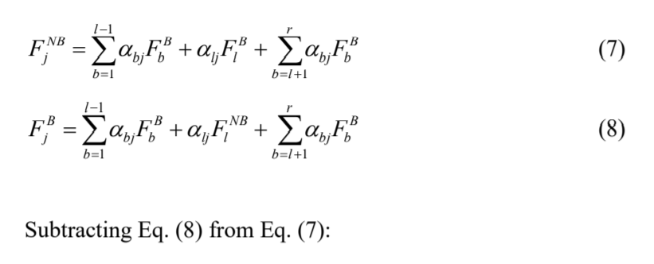

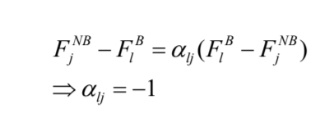

Moreover, since link l is the basis link whose column elements are a unit column vector with thelthrow element being 1,αll = 1. Hence, if αll = 1 and αlj= -1 , multiple solutions exist if the remaining column elements for the non-basis link are identical for the pair of swappable links.

**EFFECT OF NETWORK TOPOLOGY**

**1.1 Parallel highway network:**

The parallel highway network shown below is analysed using the basis link method. It consists of 4 O-D pairs, 14 links, and 9 nodes. Nodes 1 and 2 are trip origin nodes, and nodes 8 and 9 are the destination nodes.

Below table illustrates the link-path incidence matrix for the network. The Gaussian elimination algorithm is used to obtain its RREF. The basis links correspond to the 9 shaded columns in the table. They include links 1, 2, 3, 4, 5, 7, 9, 11, and 13. They represent the links on which to install vehicle sensors. Hence, about 64% of the links need to be equipped with sensors to estimate the flows on all links in the parallel highway network under steady-state conditions.

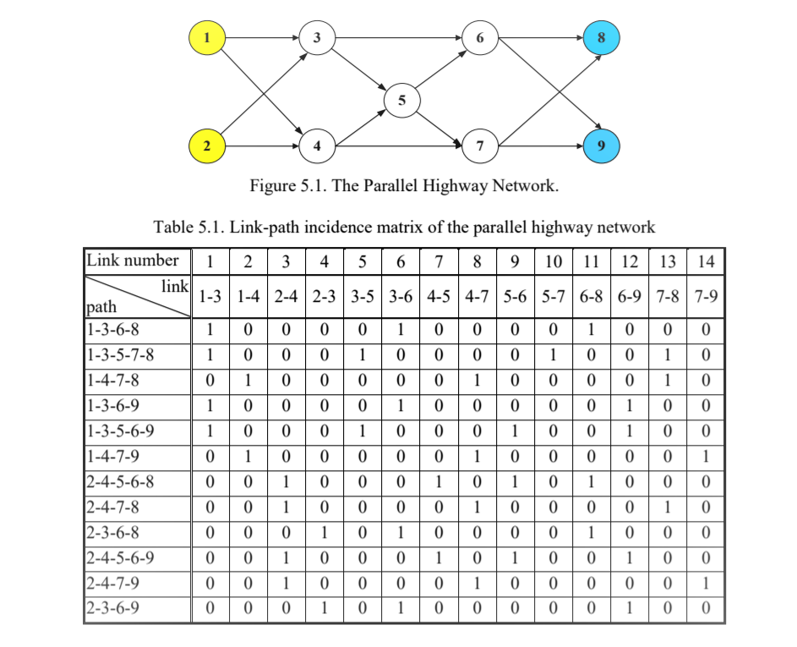**GRAPICAL VIEW OF PARALLEL HIGHWAY NETWORK AND LINK PATH INCIDENCE MATRIX**

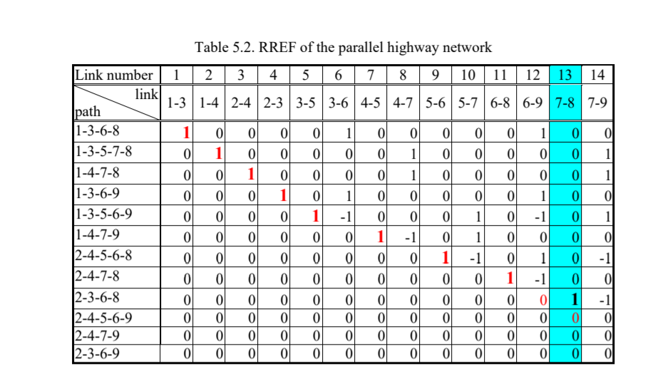**ROW REDUCED ECHLEON FORM**

**1.2 FISHBONE NETWORK**

The second network analyzed is the fishbone-shape network shown in below figure. It contains 4 O-D pairs, 18 links, and 10 nodes. Nodes 1 and 2 are the origin nodes, and nodes 9 and 10 are the destination nodes. The RREF of the link-path incidence matrix of the fishbone network is obtained by the Gaussian elimination algorithm and identifies 12 basis links: 1, 2, 3, 4, 5, 6, 8, 9, 10, 13, 14, and 17. Hence, in this 18-link network, only 12 sensors are needed to obtain the flow information on all links. Thereby, only 67% of the network links need to be equipped with sensors.

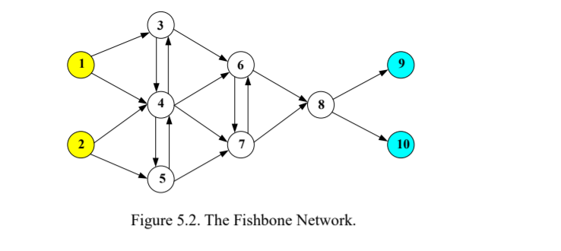

**NON-MATHEMATICAL APPROACH**

**(STEPS THAT WOULD HELP CONTROL THE JAMITON)**

**A. Priority Queue:**

The current system of traffic lights utilizing fixed-time isolated approach results in several irrational cases in traffic, a lot of vehicles are legally compelled to stop in front of red light while nothing travels on front crossroads. These cases not only cause traffic congestions within crossroads and in front of traffic lights but also result in great losses in socio-economic development. This situation can be improved if the current system of traffic lights is replaced with a more intelligent system, where right-of-way is dedicated to directions going through crossroad based on priority.

This study proposes an approach to priority-based controlling traffic lights at a crossroad. According to the approach, right-of-way is not dedicated to directions based on a fixed program as the current system, on the contrary, it is dedicated to directions of higher priority based on sequence of directions arranged in descended order of priority.

Priority Queuing (PQ) is a Congestion Management technique. PQ schedules traffic such that the higher-priority queues "always" get serviced first so that people don’t have to wait unnecessarily in the queue.

We use rate controlled priority queueing which limits the amount of high-priority traffic so that lower priority traffic can be scheduled. In other words, rate-controlled priority queueing schedules vehicles from higher priority queues before vehicles from lower priority queues as long as the amount of traffic in the higher priority queue stays below a certain threshold.

**B.** Exclusive lanes for public transport, ensure the use of traffic regulations and traffic

engineers to control the traffic.

**C.** Use innovative ideas to reduce traffic impacts on public transport.

**CONCLUSIONS:**

* Addresses the network sensor location problem (NSLP) directly so as to obtain the unobserved link flows given the minimum subset of observed link flows provided by passive counting sensors.
* Analyzes the corresponding theoretical aspects related to the proposed basis link method in the determination of the minimum subset of network links to infer unobserved link flows.
* Given the network structure represented by its **link-path incidence matrix**, a theoretical minimum subset of network links provided by the reduced row echelon form (RREF) algorithm does exist, and a direct mapping between the basis link flows and the non-basis link flows is also theoretically proved.
* The study illustrates the **possibility of multiple solutions** in terms of the set of basis links. However, that does not affect the uniqueness in terms of the inferred link flows.
* The empirical analysis highlights the primacy of the network topology in determining the set of basis links. It also indicates the possibility of an upper bound on the number of basis links based on the topology, suggesting that it may not be necessary to equip every link with sensors from a planning perspective.

**FUTURE RESEARCH DIRECTIONS:**

This research has proposed a linear algebraic approach for the determination of the minimum subset of equipped links to infer the flows on the unobserved links. The proposed basis link method provides network full observability without requiring any assumptions in terms of the knowledge of O-D flows, path flows, user route choice behavior, or traffic assignment rules. This property has broader implications in terms of potentially aiding in solving a range of problems (such as O-D demand estimation, travel time estimation, traffic assignment) in both the static and dynamic contexts. Therefore, a straightforward research direction is to estimate O-D demands for a general network, in an integrated manner, based on the (full) link flow information provided by the proposed basis link approach. Further, the existence of multiple solutions provides some flexibility for traffic agencies in choosing the links to install sensors on. That is, a traffic agency 46 may prefer to install sensors on some links because of their importance based on one or more criteria related to objectives such as minimizing deployment costs, reducing traffic impacts, or the relative importance of a link (based on the facility type or its criticality for disaster response, etc.). In such instances, priority rankings provided by the agency can be seamlessly adapted with the proposed basis link method. This is another immediate research issue that is worthy of further investigation.

**REFERENCES**

1. <http://www.m-hikari.com/ijcms/ijcms-2014/13-16-2014/aduIJCMS13-16-2014.pdf>
2. <https://www.researchgate.net/publication/330704165_Mathematical_Model_for_Traffic_Flow>
3. <http://www.ijetsr.com/images/short_pdf/1508828853_753-763-bbec447_ijetsr.pdf>
4. <https://www.purdue.edu/discoverypark/nextrans/assets/pdfs/completedprojects/Final%20Report%20018.pdf>
5. <https://www.researchgate.net/publication/298716558_Approach_to_Priority-Based_Controlling_Traffic_Lights>